Salary Caps
A Salary Cap is an agreement or rule that places a limit on the amount of money that a team can spend on player salaries. Salary caps, which exist in most major league sports, are one of several mechanisms that allows a club of billionaire sports team owners to collectively control and suppress the wages of young athletes ( cited from priceonomics.com). The NFL announced the 2015 salary caps Monday, setting the official number at $143.28 million. In fact, that’s higher than previous projections, including the $140-143 million range that was reported by ESPN’s Adam Schefter earlier in February and the $138.6-141.8 million in December. That is an august amount for an athlete to make. Many people think there should be salary caps, and some think they shouldn’t. I believe there should be salary caps in major league sports.

Why Should There Be Salary Caps?
Salary caps help limit the amount of money an athlete is allowed to get paid. Athletes that doesn’t play much or aren’t that good are still making millions just for being on the team. They also keep teams leveled. If there weren’t salary caps, the richest owners could offer the best players more money, making their teams better than most. The smaller teams wouldn’t win many games because all of the good players are on one team. This would cause less people coming to the games, which means even less money to spend on good players. With salary caps, games are fair and enjoyable to watch.
Many people argue that teachers, or someone fighting for our country should not be paid less than a pro athlete. A man fighting for our country should be paid more someone defending a football. There are several people in our country who don’t have a job or any money. If there are salary caps, more money could go towards other things. People playing sports shouldn’t be making millions of dollars while others are poor.
How Can We Change Peoples Perspective?
To see an actual professional athletes perspective on things, we can have one talk to our class. We can invite an athlete like Lorenzo Nunez to Mr. Marc’s class one day in December. He can talk to our class about his thoughts on salary caps and how teachers should get paid more than athletes. Since he is an athlete, his opinion may be biased. After he talks to the class, we can “share a coke” with him.
Salary caps can help limit how much money athletes can make. As sports have became more lucrative, salary caps have increased. With salary caps in major league sports, the games will be fair, and everyone will make an equal amount. Therefore, there should be salary caps.
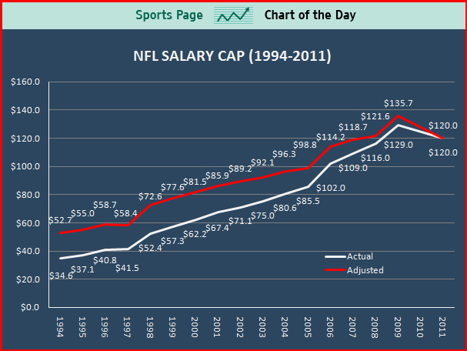
Lanie Drinnon
Persuasive
Cause/ Effect

